IOT Based Recommendations For Crop Growth Management

Abstract:
- Nowadays Internet of Things (IOT) technology is one of the fastest growing fields in different domains including agriculture. IOT improves the quality of our lives by bringing and fostering changes in many fields of activities to make them become handy, smart and endowed by sufficient artificial intelligence.
- It is mandatory to maintain good crop growth in every area like cotton, rice, jute, maize, etc., the proposed system consists of an IOT module that is used to monitor the state of each crop to grow in a good condition by providing requirements to it generally crop may not grow due to temperature rainfall moisture and pressure there are the primary requirements for which a crop to grow healthy to overcome this problem we are using sensors like water temperature, soil moisture, BME280 and wind velocity, all this sensors are connected to ESP32 and will detect the present value according to the climate and soil condition and transform the data from sensor to the cloud in which we have already stored the values, which are transformed from controller to cloud and through web app all the detected values like climate, soil condition are displayed whether in normal condition or not and if the detected values proceed and exceed it alert and gives suggestion to farmer.
- Good condition cloud after receiving data compare with the default values and through web app all the detected values will be displayed and climate, soil condition are displayed. And if the detected values proceed and exceed it alert and gives suggestion to farmer.

INTRODUCTION:
- Farming in India is done using the mundane ways. The fact that most of our farmers lack proper knowledge makes it even more erratic.
- A large portion of farming and agriculture activities are based on the predictions, which at times fail. Farmers have to bear huge losses and at times they end up committing suicide.
- Since we know the benefits of proper soil moisture and its quality, air quality and irrigation, in the growth of crops, such parameters cannot be ignored.
- We, therefore, have come up with a new idea of crop monitoring and smart farming using IOT.
- We believe that our concept will be a benchmark in the agribusiness due to its reliability and remote monitoring.
- Our idea tries to digitalize farming and agricultural activities so that the farmers can check on the requirements of the crops and accurately predict their growth.
- This concept will surely accelerate their business to reach new heights and also be more profitable.
- The implementation of our project largely depends upon the awareness among farmers, which we believe will be easily created due to its numerous advantages.

OVERVIEW:
IOT technology helps in collecting information about conditions like weather, moisture, temperature and fertility of soil, Crop online monitoring enables detection of level of water, pest detection, crop growth, and agriculture.

PURPOSE:
The aim of this project is to introduce the latest technology into the agriculture business and better crop production by collecting real time status of crop and informing the farmers about it.

LITERATURE SERVEY:
EXISTING PROBLEM:
Agriculture is the back bone of our Nation. In olden days farmers used to guess the fertility of soil and made assumption to grow which type of crop. They didn’t know about the moisture, level of water and particularly weather condition which terrible a farmer more. They use pesticides based on some assumption which made lead a serious effect to the crop if the assumption is wrong. The productivity depends on the final stage of the crop on which farmer depends.
Drawbacks of Existing System:
• Productivity may or may not be more
• We cannot estimate weather conditions as pollution is increasing gradually etc.

PROPOSED SOLUTION:
To enhance the productivity of the crop there by supporting both farmer and nation we have to use the technology which estimates the quality of crop and giving suggestions. Wireless sensor network are sensors of different types are used to collect the information of crop conditions and environmental changes these information is transmitted through network to the farmer or devices that initiates corrective action. Some disadvantages in communication must be overcome by advancing the technology to consume less energy and also by making user interface ease of use. The main objective of this project is to design a smart Agriculture in order to monitor a crop growth. Initially the system will collects all the parameters regarding the crop.

THEORETICAL ANALYSIS:
BLOCK DIAGREM:
Power supply

CLOUD SERVICES
Temperature
Sensor
END User

IOT Devices
Humidity
Sensor

Mobile App

Moisture
Sensor

Water Level
Sensor

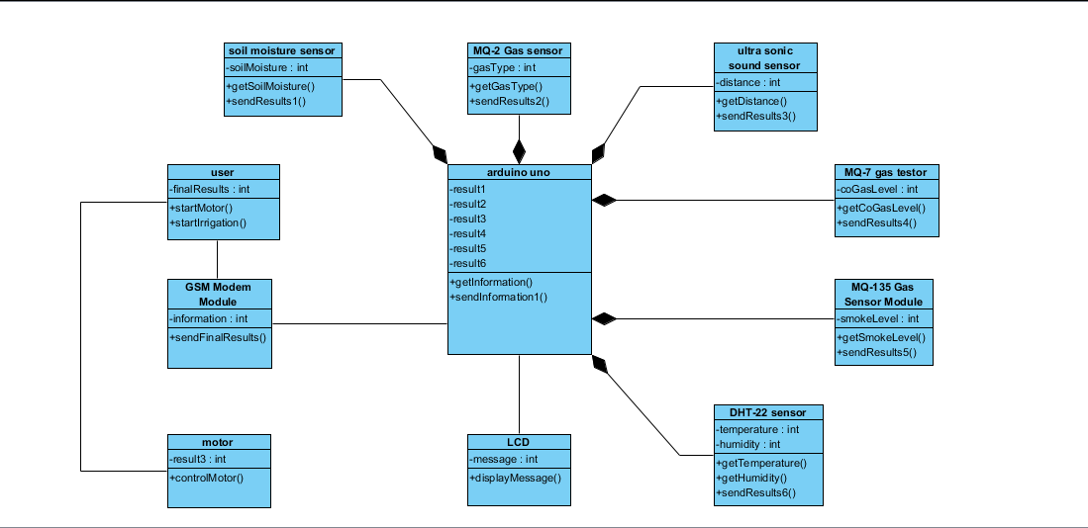
FLOW CHART:
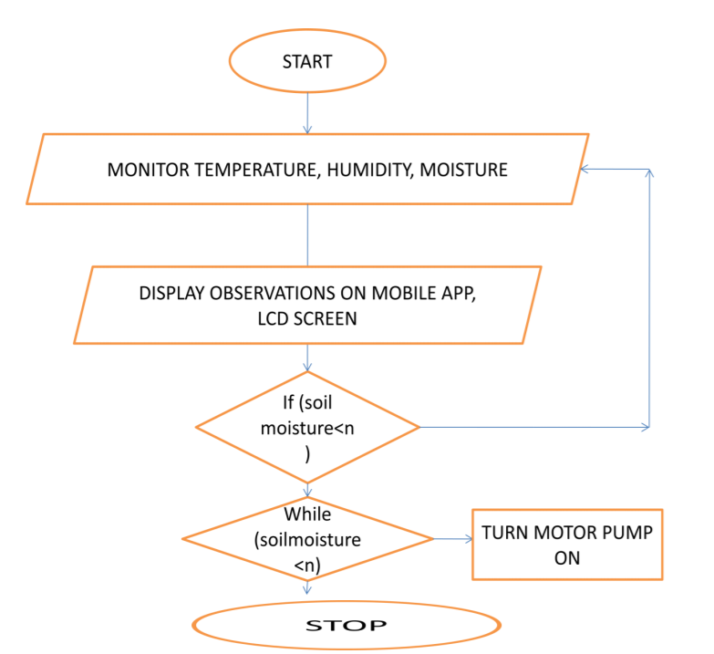
HARWARE / SOFTWARE DESIGNING:

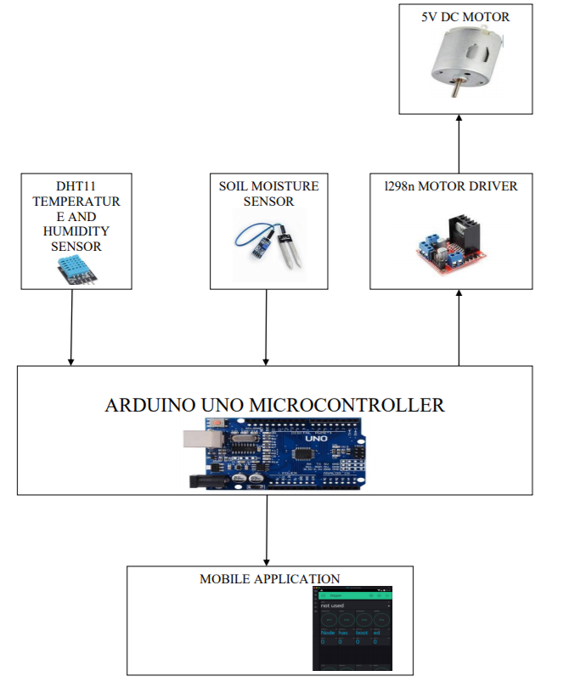

EXPERIMENTAL INVESTIGATION:
- I and our team decided to do a project for farmers which is very helpful for them to decide which crop is suitable for their soil based on soil weather, temperature, pressure called “recommendations for crop growth”.
- The present project deals with smart farming system, which would allow farmers access to live data such as temperature, humidity, and soil moister. The report is structured as follows:
- The first chapter is a general knowledge about the IOT technology and the project’s topic. The second chapter contains the steeple analysis, feasibility study, project’s requirements, specifications, methodology used, project’s design process, implementation, components and technologies used, developed algorithms, the future scope and conclusions.
- IOT contains a solid mainstay of several technologies that enable networks of wireless sensors such as, embedded systems, big data, cloud computing, web services, and computer networking and protocols.
- In agriculture’s fields Internet of Things have several benefits, encompassing:
The various sensors designed for this specific field of farming that gives the opportunity to work remotely on many projects related to agriculture. The different used sensors help instantly to collect and store data easily in cloud computing services. These live data can be accessed promptly and from any intelligent smart device. As approved by experts, farmers can use the IOT systems to increase their productivity as well as the quality of their products.
- In fact, it increases profits/incomes and reduces significantly their costs. Having access promptly to exact accurate data helps in increasing the efficiency level in the use of water, pesticides, and fertilizers amounts managements. Thus, IOT would help in protecting the environment and ecosystems as well.
- We search on internet for the best project we can and we find a project which is helpful for farmers in their cultivation.
- In this project the farmers can give their weather details and soil details so that we can give suitable crop for them.
- We collect the data from internet and many other apps how to do and what to do in our project, we also interact with the guide to discuss about the project.
- At the beginning, we have to know about programming language to write the code.
- Next, implement the code and get the output.
- Further, we have to design an app for this code to get an appropriate output.
- Lastly, when farmer enters the details they can get the result.
- After implementing the app we have check whether it is working or not, if it is working then our project is done, if not we have to modify our code and app.
- We all team members search on internet of how to do and how best we can give our result for the farmers.
FLOWCHART:

RESULT:
- The result of our project is to get a suitable crop for their requirements based soil weather and conditions.

Advantages:
- The Internet of Things allows problems to be avoided and all issues which may occur during farming processes to be eliminated. Therefore the product quality is increasing and customers are having a strong high-quality product.
- Water treatment can be carried out effectively using the IoT system without the use of sensors for wasting water.
- Water treatment can be carried out effectively using the IoT system without the use of sensors for wasting water.
- The IOT device helps to track the land constantly so that steps can be taken early. It increases efficiency, decreases manual labor, decreases time and allows productive farming.
- The monitoring of the crop can be done easily by using IoT to track crop production.
- Soil control such as pH level and humidity content etc. can be easily identified so farmers can sow seeds according to the soil level.
- The amount of time saved may be very high because of the IoT program. And we can all use more energy in everyday life today

Disadvantages:
- IOT – smart farming continually requires internet connectivity. The developing countries ‘rural portion did not follow those criteria and the internet is slower.
- The IOT related equipment allows the farmer to understand the use of technology and to learn. It is the biggest challenge for the large-scale implementation of smart agricultural framing across the countries.
- Given any security measures, the system offers little power and can lead to various kinds of network attacks.
- It is very complicated to plan, build, manage and allow the broad technology to IoT framework.

Applications:

1. Precision Farming:
- Precision farming, also known as precision agriculture, is anything that makes the whole process of farming accurate and controlled when it comes to raising livestock and growing crops.
- The key component of this farming technique is the use of Information Technology and various other technologies like sensors, robotics, automation vehicles, control systems, automated hardware, variable rate technology, and so on.
- The key characteristic of precision farming is the adoption of access to high-speed internet, mobile devices, and reliable, low-cost satellites (for imagery and positioning) by manufacturers.
- Precision farming is considered one of the most famous applications of IoT in the agricultural sector and it is being leveraged globally by several organizations. One of the examples is crop mertics. It is a precision agriculture organization that focuses on ultra-modern agronomic solutions. Moreover, it specializes in the management of precision irrigation.

2. Agricultural Drones:
- Technology has progressed significantly and at a higher rate in the past few years. Agricultural drones are a prime example of this development. Drones are being used in the agricultural sector to enhance many farming practices.
- The two types of drones- ground-based and aerial-based drones are being used in agriculture for crop health assessment, crop monitoring, spraying pesticides, irrigation, planting, and analyzing the field. These drones capture multispectral, thermal, and visual imagery during their flight.
- The use of drones offers many benefits such as crop health imaging, integrated GIS mapping, saving time, ease of use, and also increasing crop yields. When we combine drone technology with proper strategy and planning based on real-time data collection, we can give a high-tech makeover to the agricultural sector.
- From the data collected from drones, farmers are able to draw insights regarding plant health indices, plant counting and yield prediction, plant height measurement, canopy cover mapping, field water ponding mapping, scouting reports, stockpile measuring, chlorophyll measurement, nitrogen content in wheat, drainage mapping, weed pressure mapping, and so on.

3. Livestock Monitoring:
- Owners of large farms utilize wireless IOT applications to track the location, health, and well-being of their cattle. This information helps them to identify sick animals and henceforth separate them from the herd, take care of them, and also curb the spread of the disease among other animals. It is also useful for cutting labor costs as owners can locate their cattle with the help of IOT-based sensors.
- JMB North America is an association that offers cow checking answers for cow makers. One of the arrangements helps the cow proprietors notice cows that are pregnant and going to conceive offspring. From the calf, a sensor fueled by a battery is removed when its water breaks. This sends data to the owner or the farmer. In the time spent with the cattle giving birth, sensors allow the farmers to be more focused.

4. Smart Greenhouses:
- Greenhouse farming is concerned with increasing the yields of vegetables, crops, fruits etc. Greenhouses control the environmental factors through manual intervention or a proportional control mechanism. However, manual intervention leads to production loss, energy loss, and labor costs. This makes the whole concept of greenhouses ineffective. So, smart greenhouses are a better alternative. A smart greenhouse can be created with the help of IOT. These smart greenhouses intelligently monitor and control the climate without requiring any sort of manual intervention.
- Different kinds of sensors are used in a smart greenhouse that measure the environmental factors and assess their suitability for plants. A remote access is created by connecting the system to a cloud with the help of IOT. This eliminates the need for constant manual monitoring. The cloud server controls the data processing and applies a control action inside the greenhouse.
- The IOT sensors installed inside the greenhouse provide crucial information on temperature, humidity, pressure, and light levels. These sensors control everything from turning on the lights and opening a window to controlling temperature and cooling off, all through a Wi-Fi signal.

5. Monitor Climate Conditions:
- Climate plays an important role in crop production. Different crops require different climate conditions to grow and any little knowledge about climate heavily deteriorates the quantity and quality of crop production. IoT solutions enable the farmers to know real-time weather conditions.
- The sensors placed in the agricultural fields collect data from the environment that is used by farmers to choose a crop that can grow in particular climatic conditions.
- The whole IOT ecosystem is made up of sensors that detect real-time weather conditions like humidity, rainfall, temperature, all very crucial for crop production. These sensors are able to foresee any drastic change in the climatic conditions that can affect the production. An alert is sent to the server about the change in climate which helps to eliminate the need for physical presence. This ultimately leads to higher yields.

6. Remote sensing:
- IOT based remote sensing makes use of sensors placed along the farms such as weather stations for accumulating data that is carried forward to analytical tools for analysis. The crops can be monitored by farmers via analytical dashboards and action can be taken from the insights derived accordingly.
- Crop Assessment
These sensors placed in different corners of the farms assesses the crops to keep track of any alterations in the shape, size, light, humidity and temperature. Any deviation noted by the sensors is assessed and the farmer is informed. As a result, remote sensing aids in preventing disease spreads as well as in keeping track of the advancement of crops.
- Weather conditions
The data garnered by sensors in the case of temperature, humidity, moisture precipitation and dew detection aids in concluding the weather pattern in farms so that the cultivation is executed for appropriate crops.
- Soil quality
The analysis of soil quality aids in deciding on the nutrient value and parched sections of farms, soil drainage capacity or acidity, that permits to adjust the level of water required for irrigation and the select an advantageous type of cultivation.

7. Computer imaging:
This form of imaging mainly involves using the sensor cameras that are placed in various corners of the farm to generate images that go through digital image processing.
- Quality control : Image processing combined with machine learning makes use of images from the database to compare with images of crops for concluding the size, shape, color, and growth, as a result, adjusting the quality.
- Sorting and grading: Computer imaging can aid in sorting and grading the produce on the basis of the color, shape and size.
- Irrigation Monitoring: Irrigation over a period of time helps in mapping of irrigated lands. This helps in taking the decision in the pre harvest season of harvesting or not harvesting.
CONCLUSION:

- This capstone project gave me the chance to learn new technologies and work with new tool, this was a real proof that AUI has taught us to be long-life learners and to master self-learning before teaching us other class materials. Of course, this project is a combination of what I learned from all my computer science classes, the programming languages, the database systems and the engineering process that is important in any engineering project, all together with what I learned from other disciplines and also by myself about IOT and the use of Arduino helped me to build an embedded system.
- In general, the project was successful and worked properly and succeeded in delivering the prototype on due time. I am proud and happy for this achievement especially that this is my first real big theoretical and practical project. It enabled me to get concrete results and to realize that I can indeed build products that would be beneficial in real life and that I can customized upon demand as future projects.

FUTURE SCOPE:
For future work there are many features to develop or add to the prototype:
- Develop an IOS version of the previous application
- Add other Arduino components or increasing sensors for more features, and to fetch more data that can be collected.
- Add an artificial intelligent system to predict the production of goods.
- Integrating a GPS module to enhance this Agriculture IoT Technology to full-fledged Agriculture Precision ready product.

BIBLIOGRAPHY:
- CircuitsToday. Arduino and Soil Moisture Sensor -Interfacing Tutorial. Retreived from
http://www.circuitstoday.com/arduino-soil-moisture-sensor.
- Dfrobot. I2C 16x2 Arduino LCD Display Module. Retreived from
https://www.dfrobot.com/product-135.html.
- Lastminuteengineers. Insight In to ESP8266 Node MCU Features & Using It With Arduino IDE. Retrieved from https://lastminuteengineers.com/esp8266-nodemcu-arduino-tutorial/.

- Meola, A. (Jan 24, 2020). Smart Farming in 2020: How IOT sensors are creating a more efficient precision agriculture industry. Retrieved from
https://www.businessinsider.com/smart-farming-iot-agriculture.

- Team, D. (JUN 17, 2019). Is IOT the Future of Agriculture. Retrieved from
https://www.digiteum.com/iot-agriculture.

- TexasInstriments. (2017). LM35 Precision Centigrade Temperature Sensors. Retrieved from
http://www.ti.com/lit/ds/symlink/lm35.pdf.

APPENDIX:

SOURCE CODE:
import requests
import ibmiotf.application
import ibmiotf.device
import random
import json
import time
import os
import json
#Provide your IBM Watson Device Credentials
organization = "y0d2ux"
deviceType = "iotdevice"
deviceId = "1001"
authMethod = "token"
authToken = "1234567890"

# Initialize the device client.
T=0
H=0
RF=0
def myCommandCallback(cmd):
print("Command received: %s" % cmd.data['command'])
if cmd.data ['command'] =='motoron':
print("Starting The System To Water The Field...")
elif cmd.data['command'] =='motoroff':
print("Shutdown The Watering System...")
if cmd.command == "setInterval":
if 'interval' not in cmd.data:
print("Error - command is missing required information: 'interval'")
else:
interval = cmd.data['interval']
elif cmd.command == "print":
if 'message' not in cmd.data:
print("Error - command is missing required information: 'message'")
else:
print(cmd.data['message'])
def crop(P, K, N, humidity, temperature, ph, rainfall):
f = open('main.json')
data = json.load(f)
try:
for i in range(2200):
data[i]['humidity'] = round(data[i]['humidity'])
data[i]['temperature'] = round(data[i]['temperature'])
data[i]['ph'] = round(data[i]['ph'])
data[i]['rainfall'] = round(data[i]['rainfall'])
# print(i, data[i])
if(data[i]['P'] == P and data[i]['K'] == K and data[i]['N'] == N):
if(data[i]['humidity'] == round(humidity) and data[i]['temperature'] == round(temperature) and data[i]['ph'] == round(ph) and data[i]['rainfall'] == round(rainfall)):
return data[i]['label']
# else:
# print("No Matching Data Found...For the given Values")
except:
pass
try:
deviceOptions = {"org": organization, "type": deviceType, "id": deviceId, "auth-method": authMethod, "auth-token": authToken}
deviceCli = ibmiotf.device.Client(deviceOptions)
#..............................................
except Exception as e:
print("Caught exception connecting device: %s" % str(e))
os.sys.exit()
# Connect and send a datapoint "hello" with value "world" into the cloud as an event of type "greeting" 10 times
deviceCli.connect()
while True:
r = requests.get('https://api.openweathermap.org/data/2.5/weather?q=Vijayawada,IN&appid=d9743d5e16a053fa0ca2506cfd91b858')
data = r.json()
TAPI = round(data['main']['temp'] - 273.15)
HAPI = round(data['main']['humidity'])
PAPI = round(data['main']['pressure'])
T=25 #Temperature.
H=82 #Humidity.
N=99 #Nitrogen.
P=57 #Phosphorous.
K=38 #Potassium.
PH=6 #Ph Value.
M=54 #Moisture per Millimeters(mm).
RF=156 #Rainfall per Millimeters(mm).
RC = crop(P, K, N, H, T, PH, RF)
#Send Temperature & Humidity to IBM Watson
data = {"d":{ 'temperature' : T, 'humidity': H, 'nitrogen': N, 'phosphorous': P, 'potassium': K, 'ph': PH, 'moisture': M, 'rainfall': RF,'temperature_API' : TAPI, 'humidity_API': HAPI, 'pressure_API': PAPI, 'Recommended_Crop': RC}}
#print (data)
def myOnPublishCallback():
print ("Published Temperature = %s C" % T, "Humidity = %s %%" % H, "Nitrogen = %s" % N, "Phosphorous = %s" % P, "Potassium = %s" % K, "ph = %s" % PH, "Moisture = %s mm" % M, "Rainfall = %s" % RF, "Temperature_API = %s C" % TAPI, "Humidity_API = %s %%" % HAPI, "Pressure_API = %s" % PAPI, "Recommended Crop = %s" % RC,"to IBM Watson")
success = deviceCli.publishEvent("Data", "json", data, qos=0, on_publish=myOnPublishCallback)
if not success:
print("Not connected to IoTF")
time.sleep(1)
deviceCli.commandCallback = myCommandCallback
# Disconnect the device and application from the cloud
deviceCli.disconnect()

UI Output Screenshot:

